**M S Ramaiah Institute of Technology**

(An Autonomous Institute, Affiliated to VTU)

MSR Nagar, MSRIT post, Bangalore-54

**Literature Survey on**

**Single Pane Management of Cloud Email Security**

Submitted by

**Kush Bavishi 1MS12CS049**

Under the guidance of

|  |  |  |
| --- | --- | --- |
| **Suresh Gopathy**  **Technical Leader**  **Cisco Systems, Inc.**  **Bangalore** | **&** | **S. Rajarajeswari**  **Assistant Professor**  **Department of Computer Science & Engineering** |



**DEPARTMENT OF COMPUTER SCIENCE & ENGINEERING**

**M.S.RAMAIAH INSTITUTE OF TECHNOLOGY**

**(Autonomous Institute, Affiliated to VTU)**

**BANGALORE-560054**

[www.msrit.edu](http://www.msrit.edu)

**INTRODUCTION**

Cisco® Cloud Email Security provides cloud-based email protection, helping organizations reduce their onsite data centre footprint and reduce costs.

Cisco Cloud Email Security monitors and filters all inbound and outbound email traffic using effective policy-based data loss prevention and encryption. Its sophisticated filter strategy blocks targeted attacks using reputation, malware, and outbreak filters. Cisco Cloud Email Security uses the power of Cisco Security Talos, the largest threat detection network in the world, to provide proven, zeroday threat protection to all users wherever they are. It monitors and detects threats from:

* Over 75 TB of web data per day
* More than 1.6 million deployed devices
* More than 150 million endpoints
* More than 13 billion web requests per day
* Over 35 percent of the world’s email traffic

**METHOD**

The project tries to integrate all the Cloud Email Security Devices of a particular user into one single portal. It aims at increasing CES top-line by enabling Service Providers and Partners to host CES in their Data Centres. Currently, all devices are available on different URL’s/Domains. After the creation of this portal, Configuration (ESA – Email Security Appliance), Reporting (SMA – Security Management Appliance) and Monitoring, will all be available from a single portal. Also, security is being increased by masking the URLs of the customers’ devices, therefore reducing the chances of possible hacking attacks.

Besides integrating the devices, the portal also aims at implementing Single Sign-On using SAML. Single sign-on (SSO) is a [session](http://searchsoa.techtarget.com/definition/session)/user [authentication](http://searchsecurity.techtarget.com/definition/authentication) process that permits a user to enter one name and password in order to access multiple applications. The process authenticates the user for all the applications they have been given rights to and eliminates further prompts when they switch applications during a particular session.This greatly reduces the amount of credentials that the admins need to remember and also increases the overall efficiency. The concept on Single Sign-On is being used extensively today to improve user experience. Major companies such as Google as implanting it. The most common example is the services/apps provided by Google on the web. A single log in to the Google page provides access to all of Google’s websites, such as Gmail, YouTube, etc, without having to log in again on any of those pages. It is proven to increase efficiency and provide better User Experience for seamless access to all services.

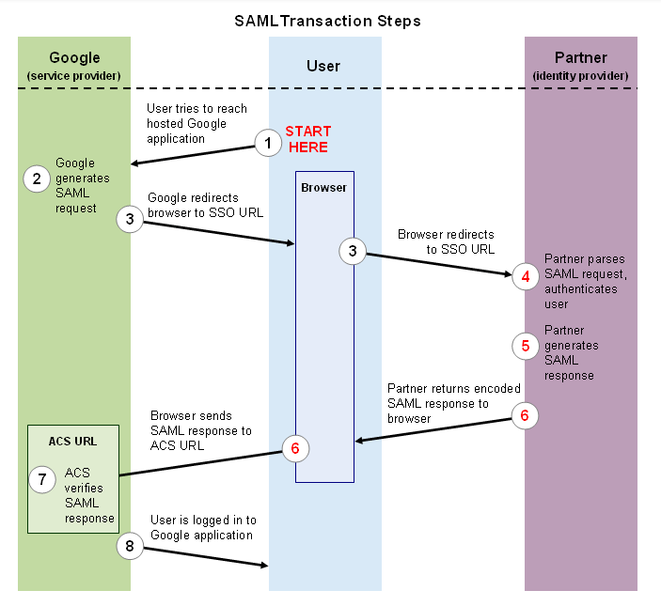

The project also aims at implementing Smart Licencing. This greatly enhances the ability of the Cisco Cloud Email Security as it provides a scalable service to customers. Currently, there is no system to be able to track the actual usage and unique users of a system. This feature tracks the unique users/usage and provide visibility to Service Providers as well as Cisco and its customers. It helps billing the clients based on their usage. The client need not pay a fixed amount for the fixed service. This increases flexibility and also boosts business for Cisco and its customers.

**CONCLUSION**

The study highlights the details of Single Pane Management of Cloud Email Security and brings out the benefits of integrating Configuration, Monitoring and Reporting, facilitating single sign on and providing user tracking for Smart Licensing and better billing of customers. Thus there will be higher cost efficiency on the customer side and also the user experience and efficiency for using Cloud Email Security.

**REFERENCES**

* https://developers.google.com/google-apps/sso/saml_reference_implementation
* http://www.cisco.com/c/en/us/td/docs/voice_ip_comm/cucm/admin/8_5_1/ccmfeat/fsgd-851-cm/fssso.html
* http://mkchendil.blogspot.in/2015/03/okta-integration-with-apache-usingmodauthmellon.html
* https://wiki.python.org/moin/PythonTraining
* https://wiki.cisco.com